PRAKTIKUM BASIS DATA

MODUL 3
03_Scripting_SQL_Basic


Oleh:

Haryanto Wifakul Azmi 103122400037

PROGRAM STUDI S1 REKAYASA PERANGKAT LUNAK
DIREKTORAT KAMPUS PURWOKERTO
UNIVERSITAS TELKOM
2026
JURNAL

- Soal 1
Jawaban:
  - Tabel FILM 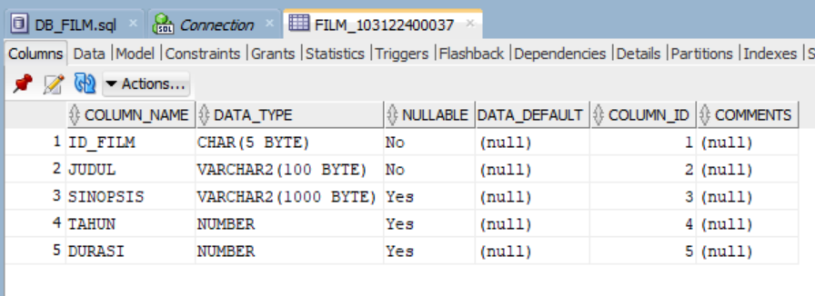Output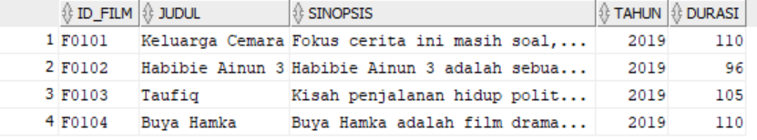
  - Tabel Inventory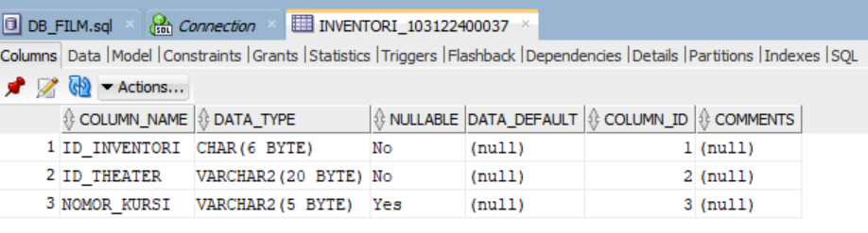
Output
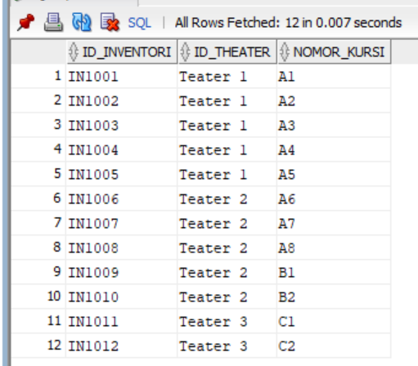
  - Tabel Jadwal
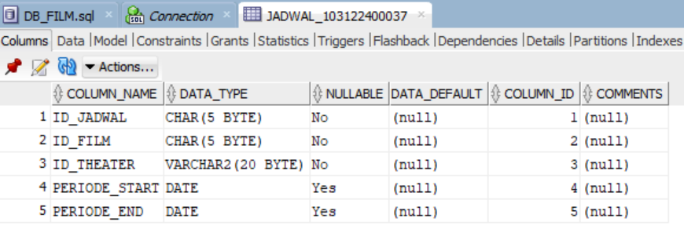
Output
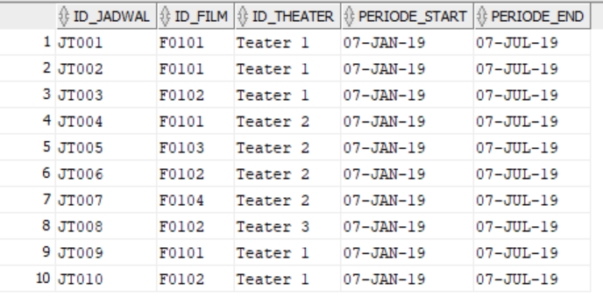
  - Tabel THEATER
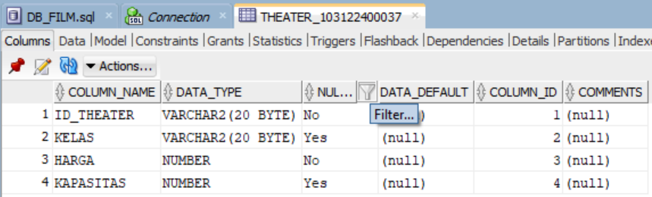
Output
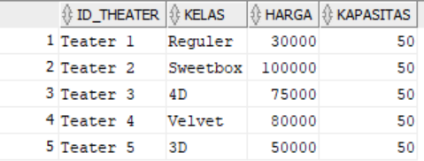
  - Tabel Transaksi
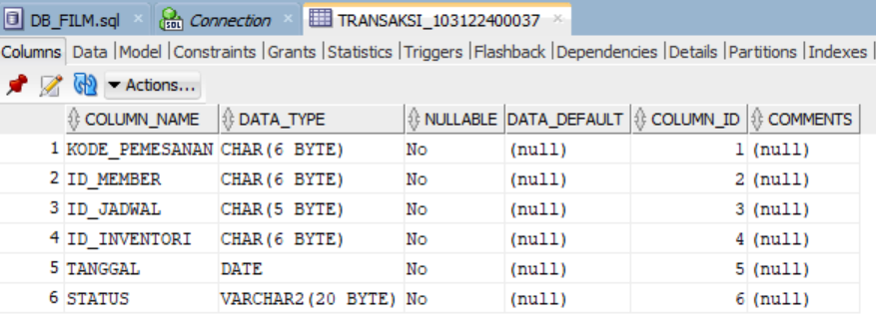
Output
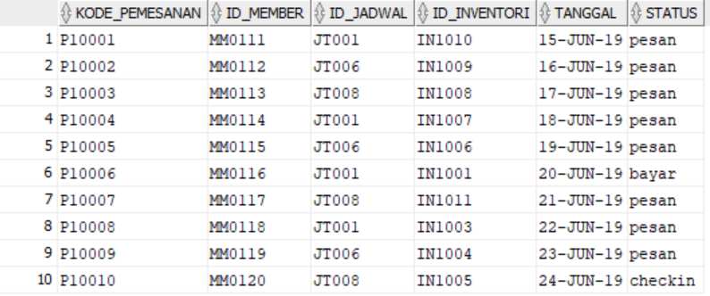

- Soal 2
Query
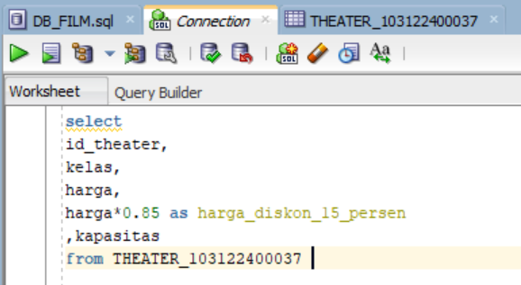
Output
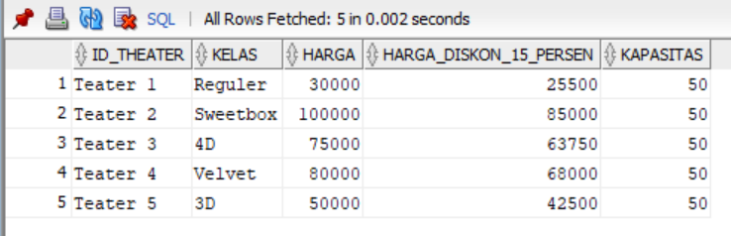

- Soal 3
Query
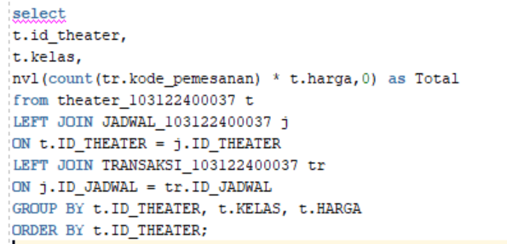
Output
